Laboratory Manual

DEPARTMENT OF COMPUTER SCIENCE AND ENGINEERING



PROGRAM - B.E
PROBLEM SOLVING and PROGRAMMING LAB (22CSC41) SEMESTER - I
R-22A Regulation

Prepared by: Verified by: ……………………………


CSE Dept.

CHAITANYA BHARATHI INSTITUTE OF TECHNOLOGY
(An Autonomous Institution, Affiliated to Osmania University, Approved by AICTE, Accredited by NAAC with A++ Grade and Programs Accredited by NBA)
Chaitanya Bharathi Post, Gandipet, Kokapet (Vill.), Hyderabad, Ranga Reddy - 500 075, Telangana
www.cbit.ac.in

CHAITANYA BHARATHI INSTITUTE OF TECHNOLOGY
(An Autonomous Institution, Affiliated to Osmania University, Approved by AICTE, Accredited by NAAC with A++ Grade and Programs Accredited by NBA)
Chaitanya Bharathi Post, Gandipet, Kokapet (Vill.), Hyderabad, Ranga Reddy - 500 075, Telangana
www.cbit.ac.in
DEPARTMENT OF COMPUTER SCIENCE AND ENGINEERING
Name of the Lab Course:
PROBLEM SOLVING and PROGRAMMING LAB (22CSC01)
INDEX

Item | Page No
Institute Vision, Institute Mission, Quality Policy, Department Vision and  Department Mission | 2
Program Educational Objectives (PEOs), Program Outcomes (POs) and  Program Specific Outcomes (PSOs) | 3
Syllabus | 7
Course Introduction | 8
Assessment Procedure of CIE and SEE | 9-10
General Instructions for Laboratory Classes | 11
Concluding Remarks / Gap Analysis | 16
LABORATORY / PRACTICAL

Exp No | Laboratory / Practical | CO | BTL | Page  No
1 | Explore various Python Program Development Environments. |  | L1 | 3
2 | Design Flowcharts using raptor / draw.io tools. |  | L3 | 25
3 | Simple scripts to demonstrate the use of basic data types and operators. |  | L3 | 27
4 | Demonstrate the use of control structures. |  | L3 | 33
5 | Experiments using Comprehensions with List, Dictionary, Set. |  | L3 | 37
6 | Implementation using Functions, Lambda functions and parameter passing. |  | L3 | 40
7 | Experiments using Searching and Sorting techniques. |  | L3 | 43
8 | Experimentation with Arrays using array and numpy modules. |  | L3 | 51
9 | Simple scripts to demonstrate the use of built-in modules.(Ex: math, random). |  | L3 | 54
10 | Demonstration of File Handling. |  | L3 | 55

CHAITANYA BHARATHI INSTITUTE OF TECHNOLOGY
(An Autonomous Institution, Affiliated to Osmania University, Approved by AICTE, Accredited by NAAC with A++ Grade and Programs Accredited by NBA)
Chaitanya Bharathi Post, Gandipet, Kokapet (Vill.), Hyderabad, Ranga Reddy - 500 075, Telangana
www.cbit.ac.in

Vision of Institute
To be the Centre of Excellence in Technical Education and Research.
Mission of Institute
To address the Emerging needs through Quality Technical Education and Advanced Research.
Quality Policy
CBIT imparts value based Technical Education and Training to meet
the requirements of students, Industry, Trade/ Profession, Research and Development Organizations for Self-sustained growth of Society.

CHAITANYA BHARATHI INSTITUTE OF TECHNOLOGY
(An Autonomous Institution, Affiliated to Osmania University, Approved by AICTE, Accredited by NAAC with A++ Grade and Programs Accredited by NBA)
Chaitanya Bharathi Post, Gandipet, Kokapet (Vill.), Hyderabad, Ranga Reddy - 500 075, Telangana
www.cbit.ac.in
DEPARTMENT OF COMPUTER SCIENCE AND ENGINEERING

Vision of the Department
To be in the frontiers of Computer Science and Engineering with academic excellence
and Research.
Mission of the Department
The mission of the Computer Science and Engineering Department is to:
- Educate students with the best practices of Computer Science by integrating the latest research into the curriculum
- Develop professionals with sound knowledge in theory and practice of Computer Science and Engineering
- Facilitate the development of academia-industry collaboration and societal outreach programs
- Prepare students for full and ethical participation in a diverse society and encourage lifelong learning
Program Educational Objectives (PEOs)
After the completion of the program, our:
- Graduates will apply their knowledge and skills to succeed in their careers and/or obtain advanced degrees, provide solutions as entrepreneurs.
- Graduates will creatively solve problems, communicate effectively, and successfully function in multi-disciplinary teams with superior work ethics and values.
- Graduates will apply principles and practices of Computer Science, mathematics and Science to successfully complete hardware and/or software-related engineering projects to meet customer business objectives and/or productively engage in research.

CHAITANYA BHARATHI INSTITUTE OF TECHNOLOGY
(An Autonomous Institution, Affiliated to Osmania University, Approved by AICTE, Accredited by NAAC with A++ Grade and Programs Accredited by NBA)
Chaitanya Bharathi Post, Gandipet, Kokapet (Vill.), Hyderabad, Ranga Reddy - 500 075, Telangana
www.cbit.ac.in
DEPARTMENT OF COMPUTER SCIENCE AND ENGINEERING

Program Outcomes (POs)
PO1. Able to gain knowledge and skills to develop, deploy and maintain software using modern Software Engineering principles and practices.
PO2. Problem analysis: Identify, formulate, research literature, and analyse complex engineering problems reaching substantiated conclusions using first principles of mathematics, natural sciences, and eering sciences.
PO3. Design/development of solutions: Design solutions for complex engineering problems and design system components or processes that meet the specified needs with appropriate consideration for public health and safety, and cultural, societal, and
environmental considerations.
PO4. Conduct investigations of complex problems: Use research- based knowledge and research methods including design of experiments, analysis and interpretation of data, and synthesis of the information to provide valid conclusions.
PO5. Modern tool usage: Create, select, and apply appropriate techniques, resources, and modern engineering and IT tools, including prediction and modelling to complex engineering activities,
with an understanding of the limitations.
PO6. The engineer and society: Apply reasoning informed by the contextual knowledge to assess societal, health, safety, legal, and cultural issues and the consequent responsibilities relevant to
the professional engineering practice.
PO7. Environment and sustainability: Understand the impact of the professional engineering solutions in societal and environmental contexts, and demonstrate the knowledge of, and need for
sustainable development.
PO8. Ethics: Apply ethical principles and commit to professional ethics

and responsibilities and norms of the engineering practice.
PO9. Individual and team work: Function effectively as an individual, and as a member or leader in diverse teams, and in
multidisciplinary settings.
PO10. Communication: Communicate effectively on complex engineering activities with the engineering community and with the society at large, such as, being able to comprehend and write effective reports and design documentation, make effective presentations, and give and receive clear instructions.
PO11. Project management and finance: Demonstrate knowledge and understanding of the engineering and management principles and apply these to one’s own work, as a member and leader in a team, to
manage projects and in multidisciplinary environments.
PO12. Life-long learning: Recognise the need for, and have the preparation and ability to engage in independent and life-long learning in the broadest context of technological change.
Program Specific Outcomes (PSOs)

At the end of the program, Graduates
PSO1. Able to acquire knowledge and practical competency for providing solutions to the problems related to Computer Science and Engineering.
PSO2. Able to design and develop innovative solutions for complex problems by applying the concepts of emerging domains including AI, ML, IoT, Data Science, security and cloud .
PSO3. Able to gain knowledge and skills to develop, deploy and maintain software using modern Software Engineering principles and practices.

22CSC41
PROBLEM SOLVING AND PROGRAMMING LAB

Instruction 0L-0T-3P
Duration of SEE 3 Hours
SEE 60 Marks
CIE 40 Marks
Credits 1.5

Course Objectives:
The objectives of this course are to:
- Master the fundamentals of writing Python scrips
- Learn Python elements such as variables, flow controls structures, and functions
- Discover how to work with lists and sequence data, and files

Course Outcomes:
After completion of course, students would be able to:
- Inspect and identify suitable programming environment to work with Python.
- Choose appropriate control constructs, data structures to design and build the solutions.
- Develop the solutions with modular approach using functions to enhance the code efficiency.
- Analyze and debug the programs to verify and validate code.
- Demonstrate use of Standard Template Libraries and modules to build file handling/Searching/Sorting applications.

Laboratory / Practical Experiments:

- Explore various Python Program Development Environments.
- Design Flowcharts using raptor / draw.io tools.
- Simple scripts to demonstrate the use of basic data types and operators.
- Demonstrate the use of control structures.
- Experiments using Comprehensions with List, Dictionary, Set.
- Implementation using Functions, Lambda functions and parameter passing.
- Experiments using Searching and Sorting techniques.
- Experimentation with Arrays using array and numpy modules.
- Simple scripts to demonstrate the use of built-in modules.(Ex: math, random).
- Demonstration of File Handling.

Text Books and References:
- R.S. Salaria, Khanna , “Programming for Problem Solving”, Book Publishing Co., Delhi.
- Jeeva Jose, Khanna , “Taming Python by Programming”, Book Publishing Co., Delhi.
- Mark Lutz, “Learning Python”, 5th Edition, , O'Reilly Media, Inc.,
- Python Crash Course: A Hands-On, Project-Based Introduction to Programming by No Starch Press.
- Eric Matthes,, “Programming in Python”, R.S. Salaria, Khanna Book Publishing Co., Delhi.
- https://www.coursera.org/specializations/python-3-programming.

NPTEL/SWAYAM Course:
- Introduction to Problem Solving and Programming, Video Lectures, Prof. D Gupta , IIT Delhi.
- Problem Solving Aspects and Python Programming, Dr. S Malinga, Dr Thangarajan, Dr. S V Kogilavani, Kongu Engineering College.

COURSE INTRODUCTION
Name of the Lab Course:
PROBLEM SOLVING AND PROGRAMMING LAB (22CSC02)
Computer Science can be summarized with two simple words: problem solving. Computer Science is the study of problems, problem-solving, and the solutions that come out of this problem-solving process.Given a problem, the goal is to develop an algorithm to solve the problem. An algorithm is a step-by-step list of instructions to solve the problem.

We design algorithms using three basic methods of control : sequence, selection, and repetition. Sequential control: Sequential Control means that the steps of an algorithm are carried out in a sequential manner where each step is executed exactly once.
Selection control: In Selection Control only one of a number of alternative steps is executed.
Repetition:In Repetition one or more steps are performed repeatedly

Solving Problems using Python
Python is a dynamic, interpreted (bytecode-compiled) language. There are no type declarations of variables, parameters, functions, or methods in source code. This makes the code short and flexible, and you lose the compile-time type checking of the source code. Python tracks the types of all values at runtime and flags code that does not make sense as it runs. Topics covered in Lab such as installation, control statements, Strings, Lists, Tuples, Dictionary, Functions, Arrays, File I/O, Programs, etc.

ASSESSMENT PROCEDURE AND AWARD OF CIE MARKS
Following is the subdivision for the internal marks (50) of the Lab:

- 20 marks for the lab internal tests

Two tests are to be conducted i.e one test after 1st cycle of experiments and second test after the second cycle. Average of two tests marks put together should be consider (20 maximum)

- 30 marks for CIE

For the CIE 30 marks will be awarded based on the rubrics provided below.

This Rubrics are general guideline. Based on the lab type (programming or hardware) and complexity of the course Rubrics can be customized by the department in tune to program and course offered. Performance Indicators of the Rubrics also can be changed by the departments/Program based on the need.
RUBRICS
 | S.  No | Parameter | Descriptors and Score
 | S.  No | Parameter | Outstanding | Good | Fair | Poor | Very Poor
 | 1 | Pre-Experiment | Well prepared | prepared for the | Adequately | Minimal | Lacks
 |  | Preparation | for the | experimentation | prepared for the | preparation and | preparation and
 |  | work | experimentation | with clear | experimentation | without clear | without clear
 |  | 5 M | with a clear | specifications | without clear | specifications | specifications
 |  |  | specifications, | and plan/design | specifications and | and plan/design | and
 |  |  | plan/design | (4M) | plan/design (3M) | (2M) | plan/design (1
 |  |  | and additional |  |  |  | M)
 |  |  | information
 |  |  | (5M)
 | 2 | Experimentatio | Student | Student solves | Student solves | Student solves | Student fails to
 |  | n (Problem | conducts | the problem and | the problem and | the problem with | solve the
 |  | Solving, | experiment with | conducts | conducts | few test cases | problem (2M)
 |  | Methodology | all possible test | experiments | experiment with | with complexity
 |  | of Conduction) | cases in an | with all possible | few possible test | (4M)
 |  | 10 M | optimized | test cases (8M) | cases with
 |  |  | fashion.(10M) |  | complexity (6M)
 | 3 | Post | Demonstrates | Demonstrates | Demonstrates | Demonstrates | Failed to
 |  | Experiment | the simulation/ | results and | results and | Partial results | Demonstrates
 |  | Analysis [Viva, | findings | inference; | inference; | and inference; | results and
 |  | Inference] | /Hardware | Able to answer | Unable to answer | Unable to answer | inference;
 |  | 5M | results Infers | Few Questions | the Questions | the Questions | Unable to
 |  |  | and answer all | posed by | posed by | posed by | answer the
 |  |  | the Questions | Instructor (4M) | Instructor. (3M) | Instructor (2M) | Questions
 |  |  | posed by |  |  |  | posed by
 |  |  | Instructor |  |  |  | Instructor (1M)
 |  |  | (5M)
 | 4 | Report Writing | Report meets all | Report with | Report is | Report is | Report is
 |  | 5M | requirements | well-organized | complete and | complete, poor | incomplete,
 |  |  | and it is | content, visuals, | adequate with | grammar and | unclear, poor
 |  |  | prepared in | graphics, | poor grammar. | inadequate and | grammar and
 |  |  | original and | citations and | (3M) | failed to organize | inadequate
7 | P a g e

 | S.  No | Parameter | Descriptors and Score
 | S.  No | Parameter | Outstanding | Good | Fair | Poor | Very Poor
 |  |  | creative way to engage readers (5M) | references (4M) |  | thoughts (2M) | (1M)
 | 5 | Conduct (Ethics, Safety, Team Work) 5M | Excellent team spirit, strictly follows ethics and safety precautions with good team  work (5M) | Follows the safety precautions, practices ethics and poor team work (4M) | Follows safety precautions and ethical practices and failed to exhibit teamwork.  (3M) | Followed minimum safety precautions and ethical practices and failed to exhibit team  work. (2M) | Does not Follows safety precautions and ethical practices and failed to exhibit team  work. (1M)
 | TOTAL SCORE
8 | P a g e

ASSESSMENT PROCEDURE AND AWARD OF SEE MARKS
 | S.  No. | Parameter | Descriptors and Score
 | S.  No. | Parameter | Outstanding | Good | Fair | Poor | Very Poor
 | 1 | Record | The content of all | The content of | The content of | The content of | The content of the all the experiments is not well- organized, recorded the tables, neatly drawn graphs.  Results and discussion are not presented  (1M)
 |  | 5 M | the experiments is | most of the | the most of | the few
 |  |  | well-organized, | experiments are | experiments | experiments is
 |  |  | recorded the tables | well-organized, | are well- | not well-
 |  |  | and neatly drawn | recorded the | organized, | organized,
 |  |  | graphs. Results and | tables, neatly | recorded the | recorded the
 |  |  | discussions are well | drawn graphs. | tables, neatly | tables, neatly
 |  |  | presented. (5M) | Results and | drawn graphs. | drawn graphs.
 |  |  |  | discussion are | Results and | Results and
 |  |  |  | presented. (4M) | discussion are | discussion are
 |  |  |  |  | not presented | not presented
 |  |  |  |  | (3M) | (2M)
 | 2 | Write up | Presentation of the | Presentation of the | Presentation of | Presentation of the given experiment/pro gram is minimal with clear specifications and plan/design. (4M) | Presentation
 |  | about the | given | given | the given |  | of the given
 |  | experiment | experiment/progra | experiment/progr | experiment/pr |  | experiment/p
 |  | 10M | m is very well | am is organized | ogram is |  | rogram is
 |  |  | organized with the | with the required | organized and |  | minimum
 |  |  | required content, | content, | is without clear |  | without clear
 |  |  | specifications, | specifications, | specifications |  | specifications
 |  |  | plan/procedure of | plan/procedure of | and |  | and
 |  |  | the conduct and all | the conduct. | plan/design. |  | plan/design.
 |  |  | the required | (8M) | (6M) |  | (2M)
 |  |  | additional
 |  |  | information. (10M)
 | 3 | Conduction | Conducts | Conducts | Conducts | Conducts | Failed to
 |  | of the | experiment / | experiment / | experiment / | experiment / | Conducts
 |  | experiment | Simulate the | Simulate the | Simulate the | Simulate the | experiment /
 |  | and | problem with | problem with | problem with | problem with | Simulate the
 |  | observations | proper connections | connections / | proper | improper | problem with
 |  | 15M | / all possible test | with most of the | connections / | connections / | improper
 |  |  | cases. All the | test cases. Failed | less test cases. | less test cases. | connections /
 |  |  | possible | to note all | (9M) | (6M) | less test cases.
 |  |  | observations are | observations |  |  | (3M)
 |  |  | noted. (15M) | (12M)
 | 4 | Results & | Demonstrates the | Demonstrates the | Demonstrates | Demonstrates | Failed to
 |  | Analysis | experimental results | experimental | the | the partial | Demonstrate
 |  | 10M | with adequate | results with | experimental | experimental | the results
 |  |  | analysis / | required analysis | results, failed | results with | and least
 |  |  | simulation/ | / simulation/ | to maximum | least analysis / | analysis /
 |  |  | findings /obtained | findings | analysis / | simulation/ | simulation/
 |  |  | results /plotting the | /obtained results | simulation/ | findings. | findings.
 |  |  | graphs. (10M) | /plotting the | findings. | (4M) | (2M)
 |  |  |  | graphs. (8M) | (6M)
 | 5 | Viva-Voce | Answers most of | Answers most of | Answers only | Answers only | Failed to
 |  | 10M | the questions with | the questions with | few of the | few of the | answer
 |  |  | good analytical | good explanation. | questions with | questions with | questions.
 |  |  | explanation. (10M) | (8M) | good | nominal | (2M)
 |  |  |  |  | explanation. | explanation.
 |  |  |  |  | (6M) | (4M)
9 | P a g e

S.
No.

Parameter
Descriptors and Score
Outstanding Good Fair Poor Very Poor

TOTAL SCORE

GENERAL INSTRUCTIONS FOR LABORATORY CLASSES

DO‘S
- Without Prior permission do not enter into the Laboratory.
- While entering into the LAB students should wear their ID cards.
- The Students should come with proper uniform.
- Students should sign in the LOGIN REGISTER before entering into the laboratory.
- Students should come with observation and record note book to the laboratory.
- Students should maintain silence inside the laboratory.
- After completing the laboratory exercise, make sure to shutdown the system properly

DONT‘S
- Students bringing the bags inside the laboratory..
- Students wearing slippers/shoes insides the laboratory.
- Students using the computers in an improper way.
- Students scribbling on the desk and mishandling the chairs.
- Students using mobile phones inside the laboratory.
- Students making noise inside the laboratory.

SYSTEM REQUIREMENTS
As per the pre-requisites student can do the implementation in any IDE for PYTHON programming language. So the following system requirements are common for all the programs. Regarding Hardware requirements student need any latest multi-core processor with sufficient RAM. Only software requiremnts are given below:

Python
You'll need Python installed on your system to write, execute, and test your code. You can download the latest version from the Python website (https://www.python.org/downloads/).
Integrated Development Environment (IDE) (Optional but Recommended):
While you can write Python code using any text editor, using an IDE can greatly enhance your development experience. Some popular options are:
- PyCharm: A powerful and feature-rich IDE for Python development.
- Visual Studio Code (VS Code): A lightweight and customizable code editor with excellent Python support through extensions.
- Jupyter Notebook / JupyterLab: Ideal for interactive data exploration and visualization.

Package Management:
- pip: Python's package manager, which allows you to easily install, update, and manage third-party libraries (including data structures libraries) that are not included in the standard library.

EXPERIMENT / PRACTICAL -1

Explore various Python Program Development Environments.

DESCRIPTION:

Here are several Python Program Development Environments (IDEs) and text editors that help developers write, test, and debug Python programs efficiently. Below is a list of some popular environments, each with its features and benefits:

OBJECTIVE OF THE EXPERIMENT:
The objective of this program is to explore different Python IDE

OUTCOME OF THE EXPERIMENT:
The outcome of this program is to understand various Python Program Development Environments.

IDE 1 - IDLE
IDLE (INTEGRATED DEVELOPMENT AND LEARNING ENVIRONMENT)
BASICS : Python idle offers a full-fledged file editor,which gives you the ability to write an execute python programs from within this program

STEPS TO EXECUTE A PYTHON SCRIPT IN IDLE:
IDLE is a cross-platform Integrated Development and Learning Environment which is the same in both Windows, Unix and macOS.The Python IDLE has two main windows that can be opened concurrently and that is the Shell window and the Editor window. It is also possible to open two editor windows at the same time.In this article, we’ll show you how to run a program in Python IDLE.
- Open IDLE

- We write ,”Hello,World!” in interactive mode.(Interactive mode immediately returns the results of commands you enter into the shell.)3.We write “Hello World” in script mode
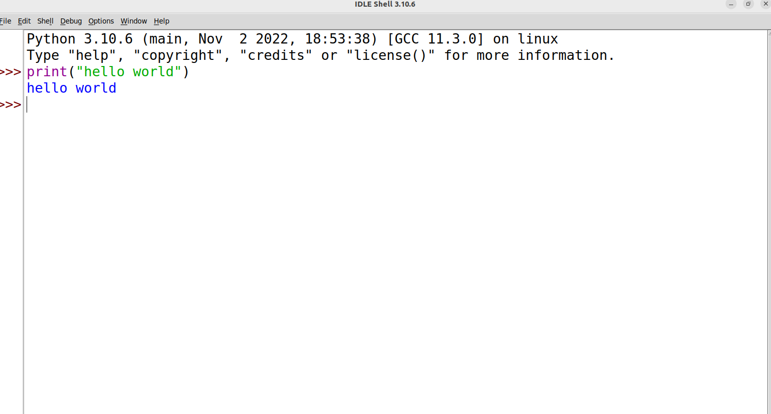

Pros:
  - Compile short bits of code.

  - Don't need to re-save.

  - Test your ideas out.

Cons:
- A file created using Python IDLE cannot be accessed from a device other than the one in which it is created unless being copied into or sent to another device.
- Changes are not saved automatically as we code.

- It is not as advanced as its contemporaries.

IDE 2 -PyCharm
PyCharm is a widely used Python IDE created by JetBrains

This IDE is suitable for professional developers and facilitates the development of large python projects

STEPS TO EXECUTE PYTHON IN PyCharm
Step 1) Open PyCharm Editor. You can see the introductory screen for PyCharm. To create a new project, click on “Create New Project”.

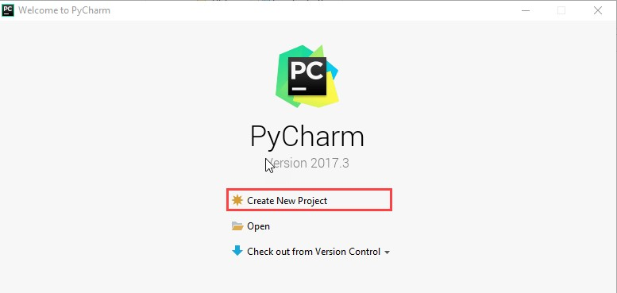

Step 2) You will need to select a location.
- You can select the location where you want the project to be created. If you don’t want to change location than keep it as it is but at least change the name from “untitled” to something more meaningful, like “FirstProject”.
- PyCharm should have found the Python interpreter you installed earlier.
- Next Click the “Create” Button
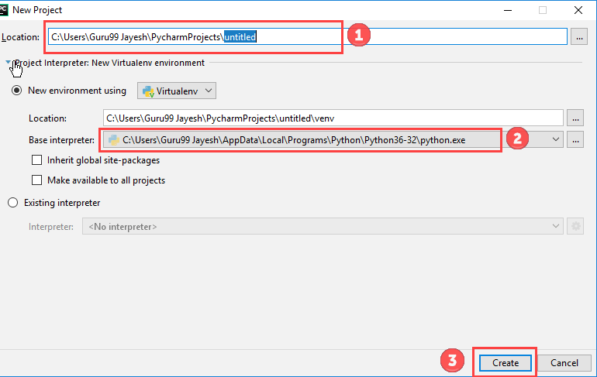
Step 3) Now Go up to the “File” menu and select “New”. Next, select “Python File”. Step 4) A new pop up will appear. Now type the name of the file you want (Here we give “HelloWorld”) and hit “OK”.
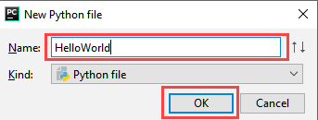

Step 5) Now type a simple program – print (‘Hello World!’).
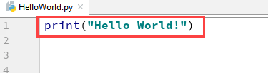
Step 6) Now Go up to the “Run” menu and select “Run” to run your program. Step 7) You can see the output of your program at the bottom of the screen.
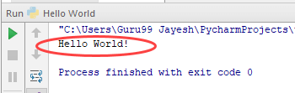

Pros :
  - Installing PyCharm is very easy.
  - There are a lot of useful plugins and productive shortcuts in PyCharm.
  - It integrates library and IDE features such as auto-completing and coloring.
  - It allows viewing of the source code in a click.
  - Software development is much faster using PyCharm

Cons :
1. The main disadvantage of using PyCharm is,it takes more space than other text editors which degrade the functionality of code.

IDE 3 - VIM
VIM-(Vi Improved) BASICS:
Vim is designed for use both from command line interface and as a standalone applications in a graphical user interface.Vim has a built-in tutorial for beginners called vimtutor which is usually installed along with Vim,but is a separate executable and can be run with a shell command.
STEPS TO EXECUTE A PYTHON SCRIPT USING VIM
- Create a python file using “vi filename.py”
- Press I or Insert button
- Copy the code and call the function
- Save the file.

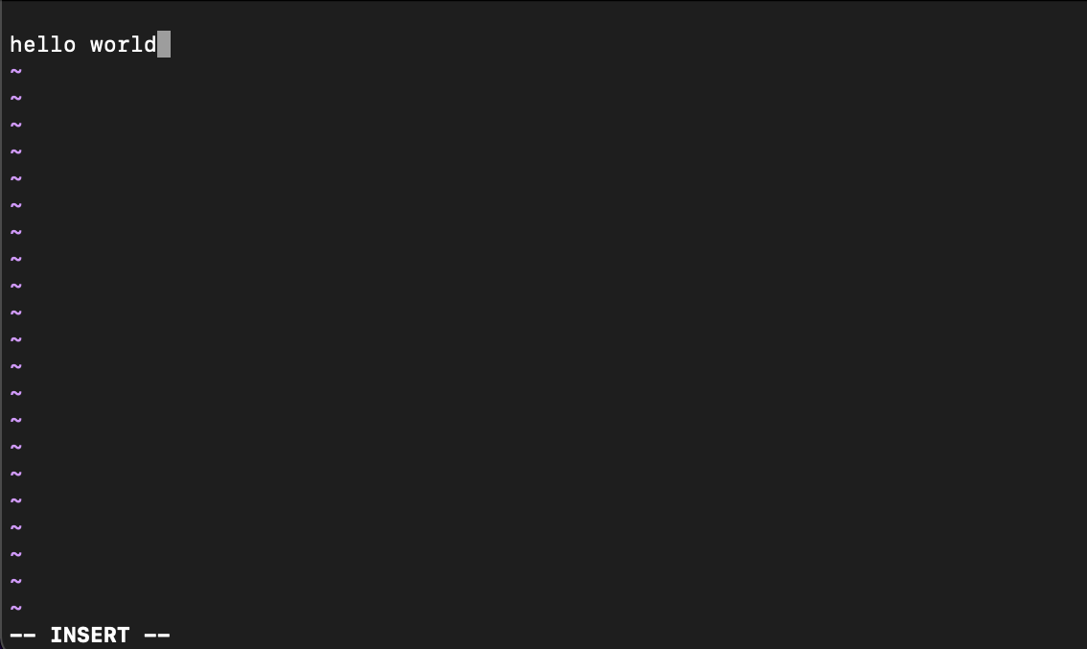

Pros:
- Vim modes enable you to not only edit,but navigate around a file or even multiple files without taking your hands away from the keys
- Vim is extremely flexible and powerful.You can start simple and use it to edit configuration files quickly

Cons:
  - The key bindings are kind of long to learn 2.It also takes time to get good settings.

IDE 4 - The Jupyter Notebook
The Jupyter Notebook is an open source web application that you can use to create and share documents that contain live code,equations, visualizations,and text.Jupyter Notebook is maintained by the people at Project Jupyter. The name Jupyter comes from the core supported programming languages that it supports : Julia,Python, and R.Jupyter ships with the IPython kernel,which allows you to write programs in Python.

STEPS TO EXECUTE PYTHON USING THE JUPYTER NOTEBOOK
Step #1: After successfully installing Jupyter write ‘jupyter notebook’ in the

terminal/command prompt. This will open a new notebook server on your web browser.
Step #2: On the top left corner, click on the new button and select python3. This will open a new notebook tab in your browser where you can start to write your first code.
Step #3: Press Enter or click on the first cell in your notebook to go into the edit mode.
Step #4: Now you are free to write any code.

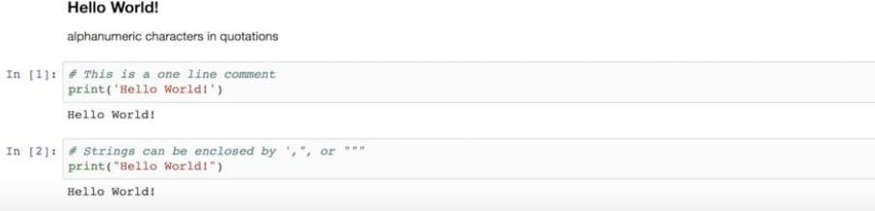
Step #5: You can run your code by pressing Shift + Enter or the run button provided at the top.

Pros :
- They’re great for showcasing your work. You can see both the code and the results

- It’s easy to use other people’s work as a starting point. You can run cell by cell to better get an understanding of what the code does.
- Very easy to host server side, which is useful for security purposes.

Cons :
1. When we’re writing code in cells instead of functions/classes/objects, you quickly end up with duplicate code that does the same thing, which is very hard to maintain.

IDE 5 - Visual Studio Code
Visual Studio Code, also commonly referred to as VS Code,is a source-code editor made by Microsoft with the Electron Framework,for Windows,Linux and macOS.Features include support for debugging,syntax highlighting,intelligent cose completion,snippets,code refactoring, and embedded Git.

STEPS TO EXECUTE PYTHON USING VISUAL STUDIO CODE

- The first command makes a directory called “helloWorld” which is our application folder.
- The second command changes our directory to “helloWorld”

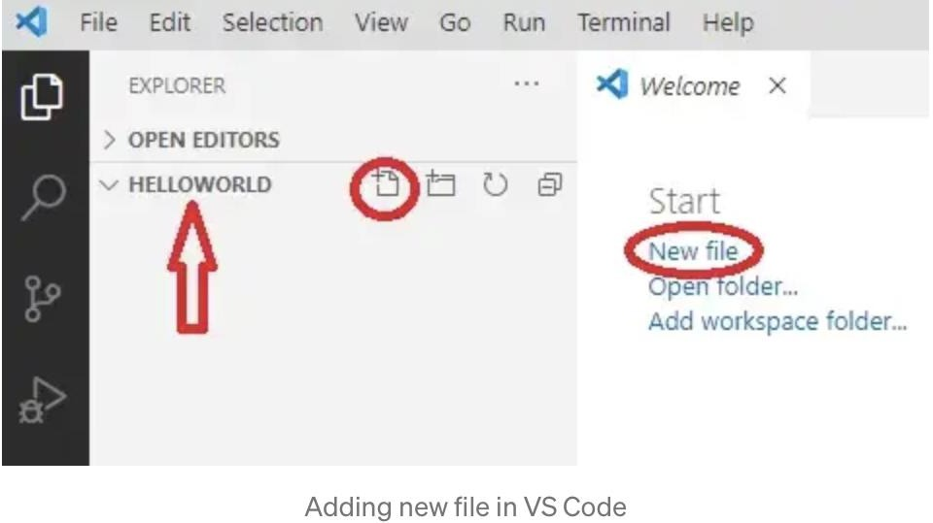
- And the third followed by a dot opens VS Code inside this folder.

So, a new folder “helloWorld” was created and VS Code was started inside it, this will become our workspace.

Click on the Run Python File in Terminal play button in the top-right side of the editor (the green) to compile it and run it at the same time.
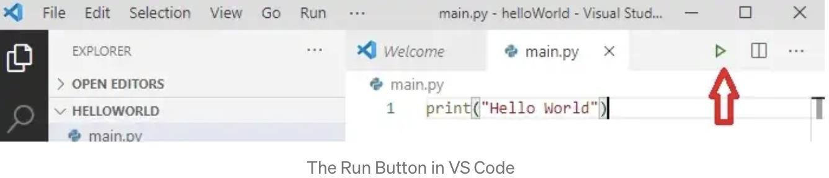

As its name, it will open a terminal at the bottom where our program was compiled/ translated by the Python interpreter (which is python.exe in Windows). The main.py file that includes our source code was given as a parameter and the output was the “Hello World” sentence that was printed on the screen.

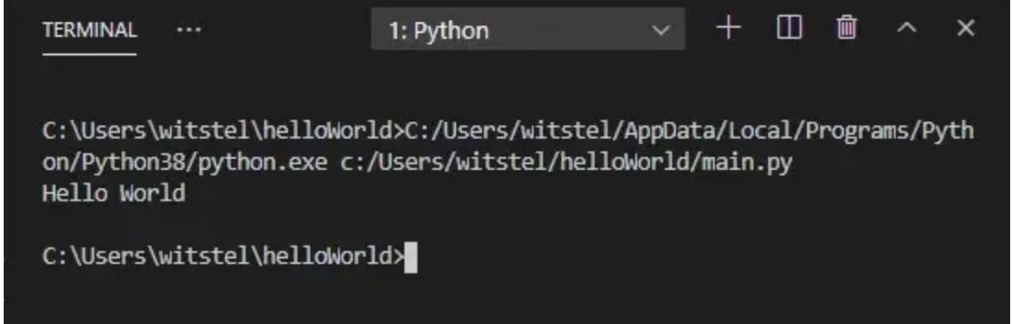

Pros :

- Robust plugin architecture replete with fantastic add-ons that make developer life delightful.
- Integrated Terminal window allows you to stay in one application to perform most required tasks.
- Customization options are robust. It is easy to modify VS Code to your own specifications.
- It's free! Hard to believe such a well made, well maintained, robust software is a free download.
- Command+P/Command+Shift+P key commands will improve your workflow dramatically.
Cons :

- Inconsistent methods to change settings. Sometimes it must be done in the JSON file. Sometimes in the UI.
- Application error messages sometimes appear without enough information to resolve them.
- Does not have built-in functionality to display SVG file preview.

Viva Questions:
- What is a Python Development Environment (IDE), and why is it important for programming?
- What are the main features of a Python IDE?
- What is the difference between an IDE and a text editor in Python development?
- How does a Python IDE help with code debugging?
- What are the advantages of using an IDE over a simple text editor for Python programming?
- What role do virtual environments play in Python development?
- What are the basic components you would expect in any Python development environment?
- How does version control (e.g., Git) integrate with Python IDEs?
- What is code completion, and why is it important in Python IDEs?

EXPERIMENT / PRACTICAL -2

Design Flowcharts using raptor / draw.io tools.

DESCRIPTION:

Design flowcharts using tools like RAPTOR or draw.io (now known as diagrams.net) provide a graphical way to represent the logical flow of a program or process. Here is a brief description of these tools and how they help in creating flowcharts for software design:

Fibonacci Series: In case of Fibonacci series, next number is the sum of previous two numbers for example 0, 1, 1, 2, 3, 5, 8, 13, 21 etc. The first two numbers of Fibonacci series are 0 and 1. Draw a flowchart for printing all the numbers in a Fibonacci series.

OBJECTIVE OF THE EXPERIMENT:
The objective of this program is to draw a flowchart to print Fibonacci series of numbers.

OUTCOME OF THE EXPERIMENT:
The outcome of this program is to understand how to solve the above problem using
Flowchart.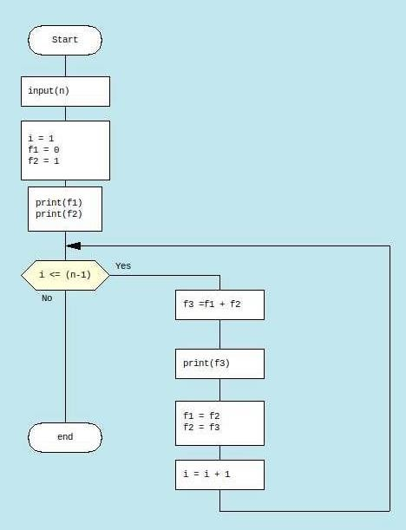
PRE LAB QUESTIONS:
- What is the need of flow charts.
- What are the symbols used to draw flowchart.
- Why we need flowchart.

Viva Questions:
- What is the use of rombhus symbol.
- Compare flowchart and algorithm.
- Discuss steps in problem solving
- What is Design step in problem solving

EXPERIMENT / PRACTICAL -3

Simple scripts to demonstrate the use of basic data types and operators.

DESCRIPTION:
Here's a simple Python script demonstrating the use of basic data types and operators:
- Integer and Float Examples: Basic arithmetic operations and differences between integer
division and floating-point division.
- String Examples: Demonstrates string concatenation and repetition.
- Boolean Examples: Illustrates boolean values and logical operations.
- Comparison Operators: Shows comparisons like greater than, equality, etc.
- Lists: Demonstrates list indexing, modification, and accessing elements.

Program 1: The displacement of a body (S) against time (t) where (u) is the initial velocity and (a) is the acceleration is given by the formula S=ut+¹/₂ at². Write a Python program to find S for given u,t,a.
Code:
u = float(input("Enter the initial velocity(m/s): "))
t = float(input("Enter the time(s): "))
a = float(input("Enter the acceleration(m/s^2): "))
S = (u*t) + (0.5*a*t*t)
print(f"The displacement of the body is {S}m.")

Output:
Enter the initial velocity(m/s): 5
Enter the time(s): 5
Enter the acceleration(m/s^2): 10
The displacement of the body is 150.0m.

Program 2: Write a Python program to demonstrate some list methods
Code:
a = [1, 2, 3, 2]
a.append(4) #Adds 4 to the end of the list
print(a)
print(a.count(2)) #Counts number of occurrences of 2 in the list
a.extend([5, 6]) #extends the list a by adding elements from list [5,6]
print(a)
print(a.index(5)) #returns the index of 5 in the list
a.insert(6,8) #inserts 8 at index 6
print(a)
a.pop() #removes the last element and returns the list
print(a)
a.reverse() #reverses the list
print(a)
print(len(a)) #returns length of the list
print(a[2]) #accesses element at index 2
print(sum(a)) #returns sum of all elements of the list

Output:
[1, 2, 3, 2, 4]

2

[1, 2, 3, 2, 4, 5, 6]

5

[1, 2, 3, 2, 4, 5, 8, 6]

[1, 2, 3, 2, 4, 5, 8]

[8, 5, 4, 2, 3, 2, 1]

7

4

25

Program 3: Write a Python program to demonstrate the various types of String methods
Code:
text = 'I LovE PythoN'
# upper() function to convert string to upper case
print("\nConverted String:")
print(text.upper())
# lower() function to convert string to lower case
print("\nConverted String:")
print(text.lower())
# converts the first character to upper case and rest to lower case
print("\nConverted String:")
print(text.title())
# splits the string into a list of words
print("\nConverted String:")
print(text.split())
# finds the number of characters in a string
print("\nLength of String:")
print(len(text))
# returns the index of first occurence of a given character
print("\nIndex of first occurence of given character:")
print(text.find(" "))
# returns the index of last occurence of a given character
print("\nIndex of last occurence of given character:")
print(text.rfind(" "))
# returns the count of a given character
print("\nCount of the given character:")
print(text.count("o"))

Output:
Converted String:
I LOVE PYTHON

Converted String:
i love python

Converted String:
I Love Python

Converted String:
['I', 'LovE', 'PythoN']

Length of String:
13

Index of first occurence of given character:
1

Index of last occurence of given character:
6

Count of the given character:
2

Program 4: Write a Python program to convert the given numbers of days into years, months and days. (Ignoring leap year).

Code:
total = int(input("Enter the number of days: "))
years = total//365
months = (total%365)//30
days = (total%365)%30
print(f"It is {years} years, {months} months, {days} days." )

Output:
Enter the number of days: 800
It is 2 years, 2 months, 10 days.

Program 5: Write a program to create a tuple of numbers to demonstrate some tuple methods.
Code:
tuple = (1, 0, 4, 2, 5, 6, 7, 5)
#returns the count a given number
print(f"\nCount of 5 in tuple is {tuple.count(5)}")
#returns the index of first occurence of a given number
print(f"\nFirst occurence of 5 is {tuple.index(5)}")
#returns the maximum number from the tuple
print(f"\nMaximum number from the tuple is {max(tuple)}")
#returns the minimum number from the tuple
print(f"\nMinimum number from the tuple is {min(tuple)}")
#returns the length of the tuple
print(f"\nThe length of the tuple is {len(tuple)}")

Output:

Count of 5 in tuple is 2

First occurence of 5 is 4

Maximum number from the tuple is 7

Minimum number from the tuple is 0

The length of the tuple is 8

Program 6: Write a Python program to demonstrate some dictionary methods.

Code:

d = {'Name':'Shyam', 'Age':'24', 'Country':'India'}
print(d.get('Name')) #returns value of Name
print(d.get('Gender')) #returns value of Gender
#If key not available retuns 'None'
print(list(d.keys())) #returns all keys as a list
print(list(d.values())) #returns all values as a list
d.pop('Age') #removes the given pair and returns the rest
print(d)
d.popitem() #returns a random pair and removes the rest
print(d)
d.clear() #empties the list
print(d)

Output:

Shyam
None

['Name', 'Age', 'Country']
['Shyam', '24', 'India']

{'Name': 'Shyam', 'Country': 'India'}

{'Name': 'Shyam'}

{}

Viva Questions:

- What are the basic data types in Python? Can you name and describe each one?
- How does Python handle data types such as integers, floating-point numbers, and strings?
- What is the difference between a mutable and immutable data type in Python?

Can you explain the difference between a list and a tuple in Python?
- What are the different types of operators in Python? Can you list and explain each type?
- What is the difference between the + operator used for string concatenation and numerical addition?

Explain how the // operator works in Python. What is the difference between / and //?
- Can you write a Python script that takes two numbers as input and swaps their values using basic assignment operators?
- How would you use logical operators to write a Python script that checks whether a number is between two other numbers?
- Write a Python script that takes a string input and checks if it contains a specific substring using the in operator.

Create a Python script that uses comparison operators to check if one number is greater than, less than, or equal to another number.

EXPERIMENT / PRACTICAL -4

Demonstration of control structures

DESCRIPTION:
- Conditional Statements (if-elif-else):
  - Demonstrates checking conditions and executing blocks of code based on whether the conditions are True or False.
- For Loop:
  - Iterates over elements in a list and performs actions on each element.
- While Loop:
  - Repeats a block of code as long as a specified condition is True.
- break and continue Statements:
  - break: Exits the loop when a certain condition is met.
  - continue: Skips the current iteration and moves to the next iteration in the loop.
- Nested Loops:
  - Demonstrates how one loop can be nested inside another to handle multi-dimensional data or complex operations.
- Using else with loops:
  - Executes a block of code after the loop ends unless a break is encountered.
This script provides a practical overview of control structures in Python, helping beginners understand how to control the flow of a program using conditional statements and loops.

OBJECTIVE OF THE EXPERIMENT:
The objective of this program is to understand if , if-else and nested if-else statements

OUTCOME OF THE EXPERIMENT:
The outcome of this program is to understand how if , if-else and nested if-else statements will work for this examples questions are considered

Program 1: Write a Python program to find the smallest the three given numbers.
Code:
num1 = float(input("Enter the first number: "))
num2 = float(input("Enter the second number: "))
num3 = float(input("Enter the third number: "))
if num1<num2 and num1<num3: #Comparing num1 with the other two
print(f"The smallest number is {num1}")
elif num2<num1 and num2<num3: #Comparing num2 with the other two
print(f"The smallest number is {num2}")
else:
print(f"The smallest number is {num3}")

Output:
Enter the first number: 21
Enter the second number: 32
Enter the third number: 43
The smallest number is 21.0

Program 2: Write a Python program to find all roots (real and equal, imaginary, equal roots of a quadratic equation).
import math
a = int(input('Enter the value of a: '))
b = int(input('Enter the value of b: '))
c = int(input('Enter the value of c: '))
d = b*b - 4*a*c
if d == 0: #When roots are real and equal
root1 = (-b) / (2 * a)
root2 = root1
print('The roots are real and equal: Root1 =', root1, ', Root2 =', root2)
elif d > 0: #When roots are real and distinct
root1 = (-b + math.sqrt(d)) / (2 * a)
root2 = (-b - math.sqrt(d)) / (2 * a)
print('The roots are real and distinct: Root1 =', root1, ', Root2 =', root2)
else: #When roots are imaginary
print('The roots are imaginary.')

Output:
Enter the value of a: 2
Enter the value of b: 5
Enter the value of c: -3
The roots are real and distinct: Root1 = 0.5 , Root2 = -3.0

Program 3: Write a Python program to find whether the person is eligible to
vote or not.
Code:
age = int(input("Enter age = "))
if age >= 18:
print('Eligible to vote')
else:
print('Not eligible to vote')

Output:
Enter age = 19
Eligible to vote

Program 4:Write a Python program to print the reverse of a given integer
Code:
#Define a function to reverse a number
def reverse_number(num):
reversed_num = 0
while num > 0:
remainder = num % 10
reversed_num = (reversed_num * 10) + remainder
num //= 10
return reversed_num
# Get input from the user
number = int(input("Enter a number: "))
reversed_number = reverse_number(number)
print("Reversed Number:", reversed_number)

Output:
Enter a number: 256
Reversed Number: 652

Program 5:Write a Python program to display the factors of a given number.
Code:
# This function computes the factor of the argument passed
def print_factors(x):
print("The factors of",x,"are:")
for i in range(1, x + 1):
if x % i == 0:
print(i)
num = int(input("Enter the number: "))
print_factors(num)

Output:
Enter the number: 320
The factors of 320 are:
1
2
4
5
8
10
16
20
32
40
64
80
160
320

VIVA QUESTIONS:
- What are control structures in programming, and why are they important?
- What are the main types of control structures in Python?
- Can you explain the concept of conditional statements in Python?
- How do Python’s if, else, and elif statements work? Can you give an example?
- What is the significance of indentation in Python control structures?
- What is an infinite loop, and how can it be avoided in Python?
- How would you write a while loop to print numbers from 1 to 10?
- What happens if the condition in a while loop is never satisfied?
- How do you use the break statement in loops? Can you give an example?
- What is the continue statement, and how does it affect loop execution?
- Can you use continue and break in the same loop? Provide an example.
- What happens if you place a for loop inside an if statement or vice versa?
- Can you demonstrate how to exit a loop early using break and still run additional code afterward
- What is the significance of control flow in complex algorithms, and how does it optimize the program execution?

EXPERIMENT / PRACTICAL -5

Experiments using Comprehensions with List, Dictionary, Set.

DESCRIPTION:
List Comprehension:
[expression for item in iterable] creates a new list based on a given expression.
You can add a condition to filter elements.
Example: squares = [x ** 2 for x in range(1, 11)] generates squares of numbers from 1 to 10.
Dictionary Comprehension:
{key: value for item in iterable} creates a new dictionary based on expressions for keys
and values.
It can be used to transform and filter data from another dictionary or iterable.
Example: {x: x ** 2 for x in range(1, 6)} creates a dictionary where keys are numbers and
values are their squares.
Set Comprehension:
{expression for item in iterable} creates a new set.
Useful for deduplication and transformation.
Example: {x ** 2 for x in range(1, 6)} generates a set of unique squares of numbers from 1 to 5.
Comprehensions are powerful tools for concise, readable, and efficient collection
transformations!

OBJECTIVE OF THE EXPERIMENT:
The objective of this program is to search whether the mobile of a given name is present in List and the dictionary, and if present then display the number.

OUTCOME OF THE EXPERIMENT:
The outcome of this program is to understand how list and dictionary is created and work with its methods.
Here's a step-by-step explanation of the outcomes of the program:
- Input: The program will prompt the user to provide name and mobile number iteratively, after addition of key-value pairs, it will prompt to enter name as search key
- Output: The program will display mobile number of the given name

Program 1: Write a Python program to convert a list of temperatures from
Celsius to Fahrenheit.
Code:

celsius = [0, 10, 20, 30, 40]
fahrenheit = [(temp * 9/5) + 32 for temp in celsius]
print("Temperatures in Fahrenheit:", fahrenheit)

Output:
Temperatures in Fahrenheit: [32.0, 50.0, 68.0, 86.0, 104.0]

Program 2: Write a Python program to invert a dictionary, swapping keys and values.

Code:
original_dict = {'a': 1, 'b': 2, 'c': 3}
inverted_dict = {value: key for key, value in original_dict.items()}
print("Inverted dictionary:", inverted_dict)

Output:
Inverted dictionary: {1: 'a', 2: 'b', 3: 'c'}

Program 3: Write a Python program to create a set of squares of even numbers from 1 to 10.

Code:
even_squares = {x**2 for x in range(1, 11) if x % 2 == 0}
print("Set of squares of even numbers:", even_squares)
#As this is a set,random order can be observed in the output

Output:

Set of squares of even numbers: {64, 100, 4, 36, 16}

Program 4: Write a Python program to create a multiplication table using list comprehensions.

Code:

multiplication_table = [[x * y for x in range(1, 11)] for y in range(1, 11)]
print("Multiplication Table:")
for row in multiplication_table:
print(row)

Output:

Multiplication Table:
[1, 2, 3, 4, 5, 6, 7, 8, 9, 10]
[2, 4, 6, 8, 10, 12, 14, 16, 18, 20]
[3, 6, 9, 12, 15, 18, 21, 24, 27, 30]
[4, 8, 12, 16, 20, 24, 28, 32, 36, 40]
[5, 10, 15, 20, 25, 30, 35, 40, 45, 50]
[6, 12, 18, 24, 30, 36, 42, 48, 54, 60]
[7, 14, 21, 28, 35, 42, 49, 56, 63, 70]
[8, 16, 24, 32, 40, 48, 56, 64, 72, 80]
[9, 18, 27, 36, 45, 54, 63, 72, 81, 90]
[10, 20, 30, 40, 50, 60, 70, 80, 90, 100]

Program 5: Write a Python program to extract unique vowels from a given string

Code:

input_string = input("Enter the string: ")
vowels = {char for char in input_string if char.lower() in 'aeiou'}
print("Unique vowels in the string:", vowels)

Output:

Enter the string: Let's learn Python
Unique vowels in the string: {'a', 'o', 'e'}

VIVA QUESTIONS:
- What is a comprehension in Python, and why is it useful?
- What are the main types of comprehensions in Python? Can you describe each one?
- How does list comprehension differ from traditional for-loop iteration?
- What is the syntax for list comprehension? Can you provide an example?
- What are the advantages of using comprehensions over conventional loops?
- How can comprehensions improve the readability and efficiency of Python code?
- Can you use comprehensions with conditions (if statements)? Provide an example.
- What is the purpose of the else statement in a comprehension? Can you explain with an example?
- What is a list comprehension in Python, and how is it different from a normal list construction using loops?
- Write a Python script that creates a list of squares of numbers from 1 to 10 using list comprehension.
- What is dictionary comprehension in Python, and how does it work?
- How is dictionary comprehension different from list comprehension?
- Write a Python script using dictionary comprehension to create a dictionary where keys are numbers from 1 to 5, and values are the squares of the keys.
- What is set comprehension in Python, and how does it differ from list and dictionary comprehensions?
- Write a Python script using set comprehension to create a set of squares of even numbers from 1 to 10.

EXPERIMENT / PRACTICAL -6
Implementation using Functions, Lambda functions and parameter passing.

DESCRIPTION:
- Functions:
Defined using the def keyword.
Can accept parameters, have a return value, and include default parameters (e.g., greet(name, greeting="Hello")).
Example: add_numbers(a, b) takes two parameters and returns their sum.
- Lambda Functions:
Also called anonymous functions.
Created using the lambda keyword, typically used for simple functions that do not need a formal definition.
Example: add_lambda = lambda x, y: x + y creates a lambda function that adds two numbers.
- Parameter Passing:
Positional Arguments: Arguments are passed in order.
Keyword Arguments: Parameters are specified by name, regardless of their order.
Default Parameters: Allows default values to be used if no argument is provided.
Variable-length Arguments:
*args (positional): Allows passing an arbitrary number of positional arguments.
**kwargs (keyword): Allows passing an arbitrary number of keyword arguments.
This script demonstrates how to use functions, lambda expressions, and different ways to pass
arguments in Python. Functions allow you to create reusable blocks of code, while lambda
functions are useful for short, throwaway functions. Different parameter-passing techniques
add flexibility to function calls.

OBJECTIVE OF THE EXPERIMENT:
The objective of this program is to identify the different functions and its usage.
def cube(y):
return y*y*y

lambda_cube = lambda y: y*y*y
print("Using function defined with `def` keyword, cube:", cube(5))
print("Using lambda function, cube:", lambda_cube(5))

Passing function as an argument in Python

# Python program to illustrate functions
# can be treated as objects
def shout(text):
return text.upper()

print(shout('Hello'))

yell = shout

print(yell('Hello'))

# Python program to illustrate functions
# can be passed as arguments to other functions
def shout(text):
return text.upper()

def whisper(text):
return text.lower()

def greet(func):
# storing the function in a variable
greeting = func("Hi, I am created by a function passed as an argument.")
print(greeting)

greet(shout)
greet(whisper)

# defining a decorator
def hello_decorator(func):

# inner1 is a Wrapper function in
# which the argument is called

# inner function can access the outer local
# functions like in this case "func"
def inner1():
print("Hello, this is before function execution")

# calling the actual function now
# inside the wrapper function.
func()

print("This is after function execution")

return inner1

# defining a function, to be called inside wrapper
def function_to_be_used():
print("This is inside the function !!")

# passing 'function_to_be_used' inside the
# decorator to control its behavior
function_to_be_used = hello_decorator(function_to_be_used)

# calling the function
function_to_be_used()

VIVA QUESTIONS
- What is a function in Python, and why are functions used in programming?
- What is the syntax for defining a function in Python?
- Can you explain the role of the return statement in a Python function?
- What are local and global variables in Python? How do they differ?
- What is the scope of a variable, and how does it relate to functions in Python?
- How do you call a function in Python after it has been defined?
- What happens if you forget to use the return statement in a function?
- What are the benefits of using functions in Python?
- Can you define a function that does not take any arguments?

EXPERIMENT / PRACTICAL -7

Experiments using Searching and Sorting techniques.

DESCRIPTION:
Linear Search:
Searches for a target element by checking each element in the list one by one.
Time Complexity: O(n), where n is the size of the list.
Binary Search:
Efficient searching algorithm for sorted lists.
Repeatedly divides the search interval in half.
Time Complexity: O(log n).
Bubble Sort:
Repeatedly steps through the list, compares adjacent elements, and swaps them if they are in the wrong order.
Simple but inefficient for large lists.
Time Complexity: O(n^2).
Quick Sort:
A divide-and-conquer sorting algorithm that selects a "pivot" element and partitions the list into elements less than, equal to, and greater than the pivot.
Recursively sorts the sublists.
Time Complexity (average case): O(n log n).
This script covers basic searching and sorting techniques commonly used in algorithms, useful for foundational understanding of data manipulation in programming.

OBJECTIVE OF THE EXPERIMENT:
The objective of this program is to search and sort the given sequence?

OUTCOME OF THE EXPERIMENT:
The outcome of this program is to understand how numbers are using various Methods
Here's a step-by-step explanation of the outcomes of the program:
Input: The program will prompt the user to provide the given sequence
Output: The program will display sorting of numbers

# Python program for Linear Search using iterative and recursive approach.

def linear_search(arr, target):
# Traverse through all elements in the array
for index in range(len(arr)):
# If the element is found, return its index
if arr[index] == target:
return index
# If the element is not found, return -1
return -1

# Example usage:
arr = [10, 23, 45, 70, 11, 15]
target = 70

# Function call
result = linear_search(arr, target)

if result != -1:
print(f"Element found at index: {result}")
else:
print("Element not found in the array")

def linear_search_recursive(arr, target, index=0):

# Base case: If index reaches the end of the list
if index == len(arr):
return -1 # Target not found

# If the target is found at the current index
if arr[index] == target:
return index # Return the index of the target

# Recursive call to check the next element
return linear_search_recursive(arr, target, index + 1)

# Example usage
arr = [10, 20, 30, 40, 50]
target = 30

result = linear_search_recursive(arr, target)

if result != -1:
print(f"Element {target} found at index {result}.")
else:
print(f"Element {target} not found in the list.")

Python Program for Binary Search Using Recursive
# Iterative Binary Search Function
# It returns index of x in given array arr if present,
# else returns -1
def binary_search(arr, x):
low = 0
high = len(arr) - 1
mid = 0

while low <= high:

mid = (high + low) // 2

# If x is greater, ignore left half
if arr[mid] < x:
low = mid + 1

# If x is smaller, ignore right half
elif arr[mid] > x:
high = mid - 1

# means x is present at mid
else:
return mid

# If we reach here, then the element was not present
return -1

# Test array
arr = [ 2, 3, 4, 10, 40 ]
x = 10

# Function call
result = binary_search(arr, x)

if result != -1:
print("Element is present at index", str(result))
else:
print("Element is not present in array")

# Python3 program for Bubble Sort Algorithm Implementation
def bubbleSort(arr):

n = len(arr)

# For loop to traverse through all
# element in an array
for i in range(n):
for j in range(0, n - i - 1):

# Range of the array is from 0 to n-i-1
# Swap the elements if the element found
#is greater than the adjacent element
if arr[j] > arr[j + 1]:
arr[j], arr[j + 1] = arr[j + 1], arr[j]

# Driver code

# Example to test the above code
arr = [ 2, 1, 10, 23 ]

bubbleSort(arr)

print("Sorted array is:")
for i in range(len(arr)):
print("%d" % arr[i])

# Selection Sort algorithm in Python
def selectionSort(array, size):

for s in range(size):
min_idx = s

for i in range(s + 1, size):

# For sorting in descending order
# for minimum element in each loop
if array[i] < array[min_idx]:
min_idx = i

# Arranging min at the correct position
(array[s], array[min_idx]) = (array[min_idx], array[s])

# Driver code
data = [ 7, 2, 1, 6 ]
size = len(data)
selectionSort(data, size)

print('Sorted Array in Ascending Order is :')
print(data)

# Python program for implementation of MergeSort

# Merges two subarrays of arr[].
# First subarray is arr[l..m]
# Second subarray is arr[m+1..r]

def merge(arr, l, m, r):
n1 = m - l + 1
n2 = r - m

# create temp arrays
L = [0] * (n1)
R = [0] * (n2)

# Copy data to temp arrays L[] and R[]
for i in range(0, n1):
L[i] = arr[l + i]

for j in range(0, n2):
R[j] = arr[m + 1 + j]

# Merge the temp arrays back into arr[l..r]
i = 0 # Initial index of first subarray
j = 0 # Initial index of second subarray
k = l # Initial index of merged subarray

while i < n1 and j < n2:
if L[i] <= R[j]:
arr[k] = L[i]
i += 1
else:
arr[k] = R[j]
j += 1
k += 1

# Copy the remaining elements of L[], if there
# are any
while i < n1:
arr[k] = L[i]
i += 1
k += 1

# Copy the remaining elements of R[], if there
# are any
while j < n2:
arr[k] = R[j]
j += 1
k += 1

# l is for left index and r is right index of the
# sub-array of arr to be sorted

def mergeSort(arr, l, r):
if l < r:

# Same as (l+r)//2, but avoids overflow for
# large l and h
m = l+(r-l)//2

# Sort first and second halves
mergeSort(arr, l, m)
mergeSort(arr, m+1, r)
merge(arr, l, m, r)

# Driver code to test above
arr = [12, 11, 13, 5, 6, 7]
n = len(arr)
print("Given array is")
for i in range(n):
print("%d" % arr[i],end=" ")

mergeSort(arr, 0, n-1)
print("\n\nSorted array is")
for i in range(n):
print("%d" % arr[i],end=" ")

# Python program for implementation of Quicksort Sort

# This implementation utilizes pivot as the last element in the nums list
# It has a pointer to keep track of the elements smaller than the pivot
# At the very end of partition() function, the pointer is swapped with the pivot
# to come up with a "sorted" nums relative to the pivot

# Function to find the partition position
def partition(array, low, high):

# choose the rightmost element as pivot
pivot = array[high]

# pointer for greater element
i = low - 1

# traverse through all elements
# compare each element with pivot
for j in range(low, high):
if array[j] <= pivot:

# If element smaller than pivot is found
# swap it with the greater element pointed by i
i = i + 1

# Swapping element at i with element at j
(array[i], array[j]) = (array[j], array[i])

# Swap the pivot element with the greater element specified by i
(array[i + 1], array[high]) = (array[high], array[i + 1])

# Return the position from where partition is done
return i + 1

# function to perform quicksort

def quickSort(array, low, high):
if low < high:

# Find pivot element such that
# element smaller than pivot are on the left
# element greater than pivot are on the right
pi = partition(array, low, high)

# Recursive call on the left of pivot
quickSort(array, low, pi - 1)

# Recursive call on the right of pivot
quickSort(array, pi + 1, high)

data = [1, 7, 4, 1, 10, 9, -2]
print("Unsorted Array")
print(data)

size = len(data)

quickSort(data, 0, size - 1)

print('Sorted Array in Ascending Order:')
print(data)

# Approach 2: Quicksort using list comprehension

def quicksort(arr):
if len(arr) <= 1:
return arr
else:
pivot = arr[0]
left = [x for x in arr[1:] if x < pivot]
right = [x for x in arr[1:] if x >= pivot]
return quicksort(left) + [pivot] + quicksort(right)

# Example usage
arr = [1, 7, 4, 1, 10, 9, -2]
sorted_arr = quicksort(arr)
print("Sorted Array in Ascending Order:")
print(sorted_arr)

VIVA QUESTIONS
- What is the difference between searching and sorting algorithms?
- Why are searching and sorting algorithms important in programming?
- What is the time complexity of sorting and searching algorithms?
- Can you explain the difference between an algorithm's best, worst, and average case time complexity?
- How do searching and sorting algorithms affect the performance of a program, especially for large datasets?

EXPERIMENT / PRACTICAL -8

Experimentation with Arrays using array and numpy modules.

DESCRIPTION
Using the array module:
array('i', [1, 2, 3]) creates an array of integers.
Basic operations like appending, removing, and indexing are shown.
Using the numpy module:
numpy.array() can create 1D, 2D, or multi-dimensional arrays.
Mathematical operations such as sum, mean, and element-wise operations are shown.
Slicing allows access to parts of arrays.
Reshaping allows changing the shape of an array (if compatible).
Special functions such as creating arrays of zeros, ones, and identity matrices are shown.
Advantages of numpy:
Fast, efficient operations on large datasets.
Support for multi-dimensional arrays.
Rich set of functionalities for numerical and matrix operations.
This script illustrates the basic functionalities and highlights the power of arrays using both the array and numpy modules.

OBJECTIVE OF THE EXPERIMENT:
The objective of this program is to implement the array using arrays and Numpy

OUTCOME OF THE EXPERIMENT:
The outcome of this program is to understand how array has been implemented using arrays and Numpy

Here's a step-by-step explanation of the outcomes of the program:
- Input: The program will prompt the user to provide the string
- Output: The program will display reverse of the given input string

#Python Program to implement the array using Numpy
import numpy as np
arr = np.array([1,2,3,4,5,6])

import numpy as np

li = [1, 2, 3, 4]
numpyArr = np.array(li)
print(numpyArr)

import numpy as np

li = [1, 2, 3, 4]
numpyArr = np.array(li)

print("li =", li, "and type(li) =", type(li))
print("numpyArr =", numpyArr, "and type(numpyArr) =", type(numpyArr))

import numpy as np

tup = (1, 2, 3, 4)
numpyArr = np.array(tup)

print("tup =", tup, "and type(tup) =", type(tup))
print("numpyArr =", numpyArr, "and type(numpyArr) =", type(numpyArr))

# Python program to demonstrate indexing in array Using Numpy?
import numpy as np

# Initial Array
arr = np.array([[-1, 2, 0, 4],
[4, -0.5, 6, 0],
[2.6, 0, 7, 8],
[3, -7, 4, 2.0]])
print("Initial Array: ")
print(arr)

# Printing a range of Array
# with the use of slicing method
sliced_arr = arr[:2, ::2]
print ("Array with first 2 rows and"
" alternate columns(0 and 2):\n", sliced_arr)

# Printing elements at
# specific Indices
Index_arr = arr[[1, 1, 0, 3],
[3, 2, 1, 0]]
print ("\nElements at indices (1, 3), "
"(1, 2), (0, 1), (3, 0):\n", Index_arr)

# Python program to demonstrate basic operations on single array
import numpy as np

# Defining Array 1
a = np.array([[1, 2],
[3, 4]])

# Defining Array 2
b = np.array([[4, 3],
[2, 1]])

# Adding 1 to every element
print ("Adding 1 to every element:", a + 1)

# Subtracting 2 from each element
print ("\nSubtracting 2 from each element:", b - 2)

# sum of array elements
# Performing Unary operations
print ("\nSum of all array "
"elements: ", a.sum())

# Adding two arrays
# Performing Binary operations
print ("\nArray sum:\n", a + b)

VIVA QUESTIONS
- What is an array in Python, and how does it differ from a list?
- What are the benefits of using arrays over lists in Python?
- How do arrays in Python handle memory compared to lists?
- Can you explain the concept of array element types (e.g., int, float, str) in
both array and numpy modules?
- What are the limitations of the built-in array module compared to numpy arrays?
- When should you choose numpy over the array module in Python?
- What is the time complexity of various operations on arrays in Python?

EXPERIMENT / PRACTICAL -9

Simple scripts to demonstrate the use of built-in modules. (Ex: math, random).

DESCRIPTION:
- math Module:
  - Provides functions for common mathematical operations like square roots, power, trigonometric calculations, factorials, etc.
  - Offers access to mathematical constants like π (pi) and e.
- random Module:
  - Provides functions for generating random numbers and performing random operations on sequences.
  - Common functions include randint(), random(), choice(), shuffle(), and sample().

Applications:
- math module: Useful for scientific computing, geometry, algebra, and other mathematical tasks.
- random module: Useful for simulations, games, sampling, random data generation, etc.
This script demonstrates how these built-in modules make it easy to perform complex mathematical and random operations without having to implement them from scratch.

OBJECTIVE OF THE EXPERIMENT:
The objective of this program is to demonstrate the use of built-in modules.(Ex: math, random).

OUTCOME OF THE EXPERIMENT:
The outcome of this program is to understand how math, random methods have been implemented

Explanation:
math module: Demonstrates basic mathematical operations like square root, trigonometric functions, and constants like pi and e.
random module: Demonstrates generating random integers, selecting a random element, shuffling a list, and generating a random float.
This script provides a simple overview of the utility of these built-in modules. Feel free to run and expand it!

import math
import random

# Demonstrating the math module
print("Math Module Demonstration")
number = 16
square_root = math.sqrt(number)
print(f"The square root of {number} is: {square_root}")

angle = math.radians(30) # Converting degrees to radians for trigonometric functions
sin_val = math.sin(angle)
cos_val = math.cos(angle)
print(f"Sin(30 degrees) is: {sin_val}")
print(f"Cos(30 degrees) is: {cos_val}")

# Demonstrating some constants
print(f"The value of pi is: {math.pi}")
print(f"The value of e (Euler's number) is: {math.e}")

print("\nRandom Module Demonstration")
# Random integer between 1 and 10
random_int = random.randint(1, 10)
print(f"A random integer between 1 and 10: {random_int}")

# Random choice from a list
choices = ["apple", "banana", "cherry", "date"]
random_choice = random.choice(choices)
print(f"A random choice from the list {choices}: {random_choice}")

# Shuffling a list
random.shuffle(choices)
print(f"Shuffled list: {choices}")

# Random float between 0 and 1
random_float = random.random()
print(f"A random float between 0 and 1: {random_float}")

VIVA QUESTIONS
- What is the random module, and how is it used in Python?
- How do you generate a random integer between two given numbers using the random module?
- How do you generate a random floating-point number between 0 and 1 using the random module?
- What is the purpose of the random.choice() function, and how would you use it to select a random element from a list?
- How can you shuffle the elements of a list using the random module?
- How do you generate a random sample of a specific size from a list without replacement using the random.sample() function?
- How can you use the math and random modules together to simulate a random angle in degrees and then calculate its sine or cosine?
- How would you generate a random number between 0 and 1 and then apply a mathematical operation (e.g., square root or logarithm) to it?
- Can you create a script that generates a random number and checks if its square root is an integer?
- How would you use the math and random modules to simulate the toss of a coin?
- How would you generate a random number and then round it to the nearest integer using math.round()?

EXPERIMENT / PRACTICAL -10

Demonstration of File Handling Operations

DESCRIPTION:
- Creating and Writing to a File:
  - with open("filename", "w") as file: opens the file in write mode ("w"), which overwrites the file if it exists or creates a new one if it does not.
  - file.write("text") writes a string to the file.
- Reading from a File:
  - with open("filename", "r") as file: opens the file in read mode ("r").
  - file.read() reads the entire content of the file.
  - You can also use file.readline() to read one line at a time or iterate through the file object to read line by line.
- Appending to a File:
  - with open("filename", "a") as file: opens the file in append mode ("a"), which adds content to the end of the file without erasing existing data.
- Reading Lines into a List:
  - file.readlines() reads all lines and returns them as a list of strings, where each string is a line from the file.
- Checking if a File Exists:
  - The os module can be used to check if a file exists using os.path.exists("filename").

Additional Notes:
- Always use the with open(...) syntax to ensure files are properly closed after the operations.
- Modes available for opening files:
  - "r": Read (default).
  - "w": Write (overwrites file).
  - "a": Append.
  - "r+": Read and write.

Output:
This script creates a file named example.txt, writes to it, reads its content, appends a new line,
and demonstrates reading line by line. This is a basic yet powerful way to manage file input/output
operations in Python.

OBJECTIVE OF THE EXPERIMENT:
The objective of this program is to copy the contents of one file into another

OUTCOME OF THE EXPERIMENT:
The outcome of this program is to understand how file is created, opened and accessed.

Here's a step-by-step explanation of the outcomes of the program:
  - Input: The program will prompt the user to provide source file name and destination file name.
  - Output: The program will copy the contents of source file into destination file

ALGORITHM / PROCEDURE:
Step 1: Get the source file name and destination file name from the user. Step 2: Open the source file in read mode.
Step 3: Open the destination file in write mode.
Step 4: Read the lines from source file and write those lines to destination file. Step 5: Repeat step-4 until end of source file is reached.

PSEUDOCODE:
Below is the pseudo-code :
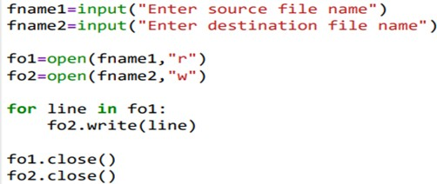

RESULTS:
Source file contents are copied to destination file.

PRE LAB QUESTIONS:
- What is the need of object oriented programming language
- How to compile and execute the program using any language selected by student

- Basic syntax for writing the logic, different operators available and different data types allowed in the selected language

SAMPLE VIVA VOCE QUESTIONS:
- How do you create a text file using Python?
- Can you explain the different modes of opening a file in Python?
- How do you read and write to an existing file in Python?
- What are some important methods used for reading from a file in Python?
- What are some common errors that can occur while working with files in Python?

B)
OBJECTIVE OF THE EXPERIMENT:
The objective of this program is to count the number of vowels in a file

OUTCOME OF THE EXPERIMENT:
The outcome of this program is to understand how file is created, opened and accessed.

Here's a step-by-step explanation of the outcomes of the program:
  - Input: The program will prompt the user to provide source file name
  - Output: The program will display number of vowels in the given file

ALGORITHM / PROCEDURE:
Step 1: Get the source file name from the user. Step 2: Open the source file in read mode.
Step 3: For each character identify vowel or consonent. Step 4: If vowel, increment the vowels count by 1.
Step 5: Repeat step-3 until end of source file is reached. Step 6: Display vowels count

PSEUDOCODE:
Below is the pseudo-code :
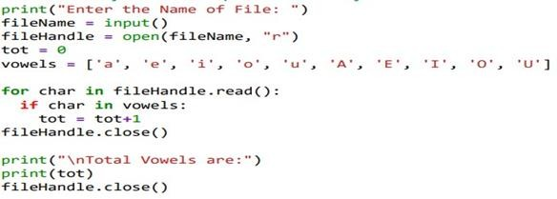

RESULTS:

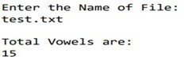

PRE LAB QUESTIONS:
- What is the need of object oriented programming language
- How to compile and execute the program using any language selected by student
- Basic syntax for writing the logic, different operators available and different data types allowed in the selected language

SAMPLE VIVA VOCE QUESTIONS:

- What is file handling in Python? Why is it important?
- What are the different modes in which a file can be opened in Python?
- How do you open a file in Python? Can you give an example?
- What is the difference between read() and readlines() methods in Python file handling?
- What happens if you try to open a file that does not exist in the specified mode?
- What is the purpose of the with statement in file handling?
- What are the common exceptions you might encounter when performing file operations in Python?
- What is the difference between file.close() and using the with statement when working with files?
- Can you explain how to handle file errors in Python, such as attempting to open a non-existent file?
- What happens when you try to open a file in 'r' (read) mode, and the file does not exist?

GAP ANALYSIS BY THE COURSE FACULTY / COORDINATOR

…………………………………………………………………..

…………………………………………………………………..

…………………………………………………………………..

…………………………………………………………………..

…………………………………………………………………..

…………………………………………………………………..

…………………………………………………………………..

…………………………………………………………………..

…………………………………………………………………..

…………………………………………………………………..

Faculty name & Signature with date

HoD/BoS Chairman remarks:

……………………………………………………………………………

……………………………………………………………………………

………………………………………………………………………….…

HoD/BoS chairman Signature with date

